Assessment 1: Job Prediction Analysis
Mathias Henry Morgan
35087056

Project Introduction
This project involves forecasting employee turnover which poses significant financial and operational risks for businesses. This report details the development of a machine learning pipeline designed to predict employee attrition, distinguishing between employees likely to stay designated as 0 and those seeking to leave designated as 1 in the “target” field of the provided data set. One of the core challenges presented by this dataset is its inherent class imbalance, ~80% of the workforce intends to remain, while ~20% represents those that intend to leave, along with many varied features provides a challenging data set to model and score effectively. The primary objective of this analysis is not merely to classify correctly, but to maximize the F1-Score. The project was split between EDA & Data transformation and the modelling stage itself, various different techniques for data analysis and pre-processing were undertaken to inform and assist with the modelling phase.
Models
Linear SVC (Support Vector Classifier): Linear Support Vector Classifier is an efficient implementation of Support Vector Machine (SVM) designed specifically for linear classification tasks. LinearSVC explicitly assumes the data is linearly separable (or nearly so) after projection into a high-dimensional space. In this analysis, it was used as a strong linear baseline to determine whether employee turnover could be effectively predicted using only linear relationships, or whether the problem inherently demands the non-linear modelling power of tree based methods.
Random Forest: Random Forest is an ensemble-learning algorithm that builds many decision trees during training and then aggregates their results. For classification problems, the final classification is chosen by majority vote across all the individual trees. This makes Random Forest a strong baseline: by averaging over many trees, it significantly reduces variance and produces more robust predictions. It works especially well for datasets that mix categorical and numerical features, without requiring extensive feature scaling.
XGBoost (Extreme Gradient Boosting): XGBoost is a fast, scalable, and optimised implementation of the gradient-boosting technique. Unlike Random Forest, which trains many trees independently, XGBoost builds trees one after another, with each new tree focusing on correcting the mistakes of the previous ones. It was selected for this project because of its strong performance on tabular datasets. Importantly, XGBoost provides built-in mechanisms for handling class imbalance through weighted learning, making it particularly effective for detecting the minority classes in imbalanced data sets.
CatBoost: CatBoost is a gradient boosting algorithm built to handle categorical features without the need for extensive preprocessing. It uses a technique called Ordered Boosting to mitigate prediction shift. Although this project applied label encoding to the categorical variables, CatBoost is still well-suited to the dataset—particularly given the presence of high cardinality fields (fields with many distinct values). In addition, CatBoost is an appropriate choice for this binary classification task as it captures non-linear relationships well and handles imbalanced data well
EDA & Data Transformation
Prior to the modelling phase of this project various EDA and data transformations tasks were undertaken to understand the data and to transform the raw set into a suitable dataset for predictive modelling tasks. basic dataset characteristics were systematically examined, including the total number of observations, column metadata, presence of duplicate records, and missing or null values. These checks revealed a clean dataset with no duplicate rows and no missing values across all features and target variables. This process confirmed that no imputation or row removal needed to occur prior to further data pre-processing. The CID field was also removed as it is a unique identifier for each individual it adds no value to the modelling process.
Target Distribution
A critical early step in this project workflow was to determine if there was in imbalance between the No (0) and Yes (0) values in the target field which is the dependent variable in this data set and the value we are attempting to predict. The result of this would greatly inform the modelling phase as will be discussed. A visual and tabula representation of the result is below:
Target | Count | Percentage
No (0) | 8,676 | 75.48
Yes (1) | 2,818 | 25.52
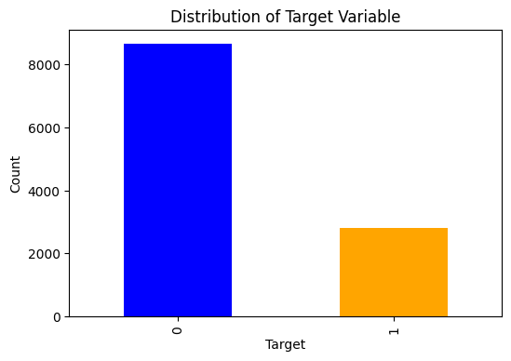
Of the 11,493 target variable values 8,676 of them are 0 or No values representing a 75.48% of the total. This is a significant imbalance and raises the question about how this should or should not be handled. On one hand we can accept this imbalance as a feature of the data and attempt to account for it in the modelling phase or perform some level of pre-processing to even out the balance. The approach chosen in this project was former, this was accepted as an inherent feature of the data set itself and was accounted for in the modelling phase as will be discussed further into the report. An attempt at SMOTE (synthetic minority over sampling technique) was done during development to attempt to even out the balance, however this result did not result in any improvement in the model’s ability to generalise and predict as seen by the F1 score. Therefore, the decision to accept the imbalance was retrospective through various unsuccessful techniques like SMOTE.
Label encoding and mapping
A key component of machine learning workflows is often to transform categorical variables in numerical variables. The approach taken in this project was to identify and isolate all categorical fields and then display a set of all unique values in each field, this was done separate ordinal and non-ordinal fields. Ordinal fields which are essentially ranked were handled with discrete 0 to n mappings to ensure consistency and to preserve the correct order of values e.g in the ‘education level’ field primary school was ranked converted to 0 as it was the lowest and PhD was given the highest value of 4. All other non-ordinal fields were converted using Label Encoder to ensure all models used could read and interpret the data.
Derived Fields
Three derived fields (fields derived from source fields) in this project were created in an attempt aid in model generalisation and pattern prediction of the target variable, this was done as a further abstraction to some existing fields to potentially offer the models higher signal for better predictive results
- training_time_ratio: this is created by dividing the hours trained with the amount of experience to determine a relationship between hours trained and experience
- highly_qual_flag: This is a binary flag that identified individuals with an education level above 3, which corresponds to master’s and above and less than three years work experience.
- highly_freq_jobs: This is a binary flag that identified individuals with over 10 years experience by are in jobs less than a year to identify those that move jobs at a high frequency.
As will be discussed further into the report, these features did not provide any meaningful signal in any of the models, the addition of these fields neither increased or decreased the F1 scores.
Mutual Information Score
One step prior to the modelling phase involved calculating the Mutual Information score for all features in the data set against the target variable. Mutual Information measures how much information one variable provides about another, Mutual Information is useful as it can capture both linear and non-linear relationships making it a versatile scoring mechanism. This was done to cross reference against information gain and potentially inform field selection during the modelling phase. As can be observed the city development index, one city category and experience contributed significantly which aligns with the information gain seen.
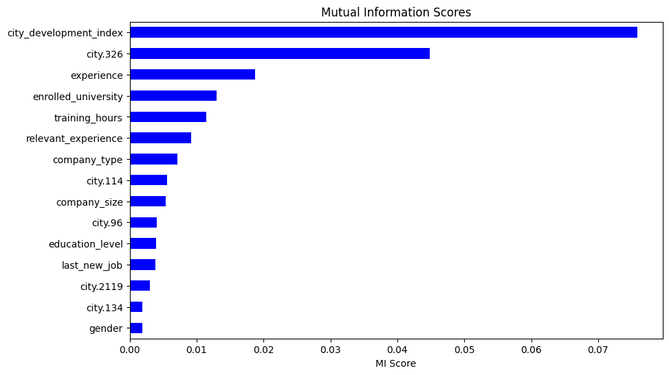
Model Scoring, Results and Interpretation
All models were assessed and internally validated using the F1 Score, commonly used to measure performance in classification tasks. The F1 Score is the harmonic mean of precision and recall that provides a quantitative measure that balances both false positives and negatives. F1 score is highly applicable in this project as contains and imbalanced target. F1 provides a robust and balanced metric
The approach taken across all models was relatively like ensure consistency across different models.
Step 1: Create test and hold out data set (for internal F1 Score validation)
Step 2: Create a Baseline Model with set hyper parameters and assess baseline F1 performance against ALL features
Step 3: Visualise Information gain of top 30 features
Step 4: Create a trimmed model using the same baseline hyper parameters but trained only on the top 30 features by information gain and select the trimmed or baseline model depending on F1 Score
Step 5: Create a hyperparameter grid and find the best parameters
Step 6: Evaluate and store model results
(Linear SVC had a n extra step related to scaling numerical features)
Results
Model | Precision | Recall | F1
XGBoost | 0.507979 | 0.677305 | 0.580547
CatBoost | 0.500000 | 0.679078 | 0.575940
Random Forest | 0.547731 | 0.620567 | 0.581879
Linear SVC | 0.503516 | 0.634752 | 0.561559

As the results above demonstrate the best performing model was unexpectedly the Random Forest model, the assumption before hand was that either XGBoost or CatBoost would product superior results. However, all models demonstrated similar level of performance judging by the F1 score.
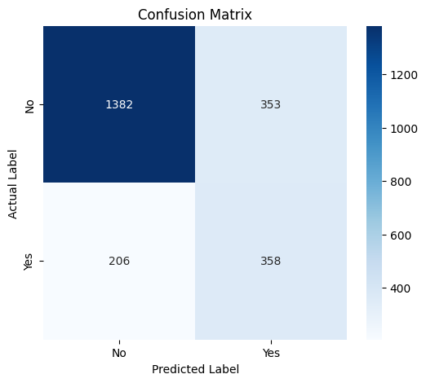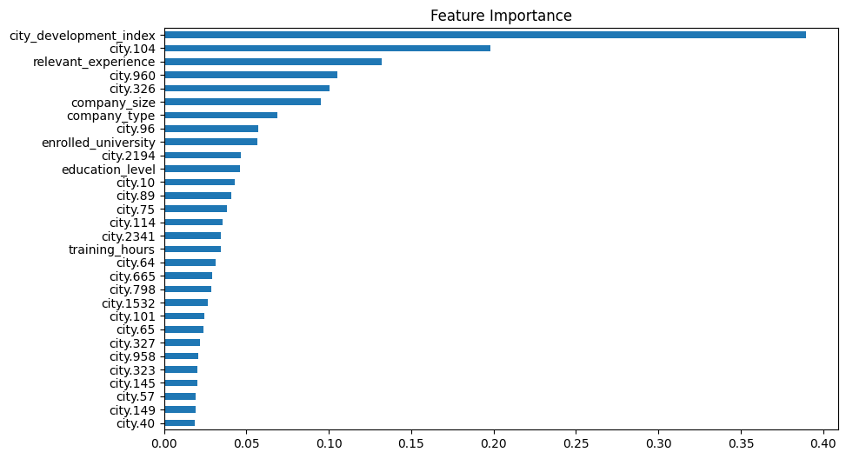

GeeksforGeeks. (2024, September 23). Linear SVC machine learning algorithm for text classification. https://www.geeksforgeeks.org/linear-svc-machine-learning-algorithm-for-text-classification/
GeeksforGeeks. (2025, October 31). Random Forest Algorithm in Machine Learning. https://www.geeksforgeeks.org/machine-learning/random-forest-algorithm-in-machine-learning/
GeeksforGeeks. (2025, October 24). XGBoost. https://www.geeksforgeeks.org/machine-learning/xgboost/
GeeksforGeeks. (2024, May 15). CatBoost in Machine Learning.. https://www.geeksforgeeks.org/machine-learning/catboost-ml/?utm_source=chatgpt.com

